CASE STUDY 9: FINAL EXAMINATION ELIGIBILITY AND COMPLIANCE CHECKER SYSTEM
1 PROBLEM STATEMENT
Design and implement an automated university examination clearance module that evaluates student readiness across multiple mandatory compliance parameters (attendance percentage, lab completion rate, internal assessment scores, and tuition fee clearance status) and provides detailed deficiency reports for ineligible candidates.
2 OBJECTIVES
- Define strict threshold standards for semester eligibility (minimum 75% attendance, 80% lab completion, and 40 internal marks).
- Enforce binary fee clearance verification alongside quantitative metrics.
- Provide robust input validation loops to handle out-of-range values and invalid data types gracefully.
- Generate transparent audit reports listing all unmet criteria or confirming final examination eligibility.
3 KEY ASSUMPTIONS
Compliance parameters are universal prerequisites established by academic regulatory policies. All percentage inputs are bounded between 0 and 100, and fee clearance requires explicit confirmation.
4 ALGORITHM
- Initialize threshold constants (MIN_ATTENDANCE, MIN_LABS, MIN_INTERNAL).
- Prompt for student name and validate numeric inputs for attendance, lab completion, and internal marks within valid ranges using helper loops.
- Prompt for fee clearance status via a boolean yes/no helper function.
- Pass all metrics to check_eligibility to compile a list of unmet requirements.
- If the problem list is empty, issue an "ELIGIBLE" status; otherwise, display all specific deficiency reasons sequentially.
5 FLOWCHART REPRESENTATION
Plaintext
[Start] -> [Input Student Name & Metrics (Attendance, Labs, Internals, Fees)]
-> [Check Attendance >= 75%? If not, add problem]
-> [Check Lab Completion >= 80%? If not, add problem]
-> [Check Internal Marks >= 40? If not, add problem]
-> [Check Fee Cleared? If not, add problem]
-> [Problems List Empty? Yes: Print ELIGIBLE | No: Print Unmet Requirements] -> [End]
6 PSEUDOCODE
Plaintext
FUNCTION check_eligibility(attendance, lab_completion, internal_marks, fee_cleared):
problems = []
IF attendance < MIN_ATTENDANCE: ADD deficiency to problems
IF lab_completion < MIN_LABS: ADD deficiency to problems
IF internal_marks < MIN_INTERNAL: ADD deficiency to problems
IF NOT fee_cleared: ADD "Fees are not cleared" to problems
RETURN problems

FUNCTION main():
Read valid student inputs
problems = check_eligibility(...)
IF length(problems) == 0: PRINT "ELIGIBLE"
ELSE: PRINT each unmet requirement
8 TEST CASES
Student Scenario | Input Metrics | Expected Outcome | Audit Result / Deficiency Message
TC-01: Fully Compliant | 85% Att, 90% Labs, 45 Marks, Fees Yes | Eligible | ELIGIBLE to appear for the final examination.
TC-02: Low Attendance | 65% Att, 85% Labs, 42 Marks, Fees Yes | Not Eligible | Attendance is 65.0% (minimum required: 75%)
TC-03: Multiple Failures | 70% Att, 75% Labs, 35 Marks, Fees No | Not Eligible | Lists 4 specific unmet requirements
9 OUTPUT SCREENSHOTS
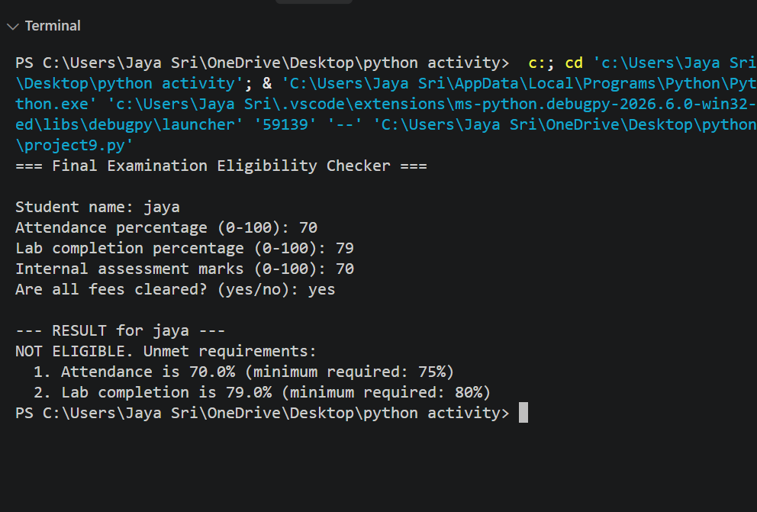
10 CONCLUSION
The examination eligibility module successfully automates multi-criteria academic audits, ensures robust input error handling, and delivers actionable compliance feedback for students and advisors.

